MARKET BASKET ANALYSIS USING APRIORI ALGORITHM ON ONLINE RETAIL DATA
Abstract
Market Basket Analysis is a data mining technique used to identify relationships among products purchased together by customers. This project uses the Online Retail Dataset and applies the Apriori Algorithm to discover frequent itemsets and association rules. The results help identify customer buying patterns and provide valuable insights for product recommendations, cross-selling, and promotional strategies. The analysis was implemented using Python and the MLxtend library.
Introduction
Market Basket Analysis (MBA) is one of the most widely used techniques in retail analytics. It helps businesses understand customer purchasing behavior by identifying products that are frequently bought together. The knowledge gained from MBA can be used for store layout optimization, product bundling, recommendation systems, and targeted marketing campaigns.
The Apriori Algorithm is a popular association rule mining technique used to discover frequent itemsets and generate association rules from transaction data.
Objectives
- To analyze customer transaction data.
- To identify frequently purchased product combinations.
- To generate association rules using the Apriori Algorithm.
- To provide business recommendations based on purchasing patterns.
- To visualize frequent itemsets and association rules.
Dataset Description
The project uses the Online Retail Dataset containing transactions of a UK-based online retail company.
Dataset Characteristics:
- Total Records: 541,909
- Number of Attributes: 8
- Transaction-Based Dataset
- Contains Invoice Number, Product Description, Quantity, Unit Price, Customer ID, and Country.
Attributes:
- InvoiceNo
- StockCode
- Description
- Quantity
- InvoiceDate
- UnitPrice
- CustomerID
- Country
Methodology
Data Cleaning
The following preprocessing steps were performed:
- Removal of cancelled transactions.
- Removal of missing product descriptions.
- Removal of records with negative quantities.
- Creation of transaction baskets using Invoice Numbers.
Basket Creation
Transactions were transformed into a binary matrix where:
- 1 = Product Purchased
- 0 = Product Not Purchased
Apriori Algorithm
The Apriori Algorithm was applied with a minimum support threshold of 2%.
Association Rule Mining
Association rules were generated using:
- Confidence
- Support
- Lift
Implementation
Python Libraries Used:
- Pandas
- MLxtend
- Matplotlib
- OpenPyXL
Steps:
- Import Dataset
- Clean Data
- Create Basket Matrix
- Apply Apriori Algorithm
- Generate Association Rules
- Visualize Results
Results
After preprocessing:
- Transactions: 20,136
- Products: 4,077
- Products considered for analysis: 200
- Frequent Itemsets Generated: 16
Top Association Rules:
- ALARM CLOCK BAKELIKE GREEN → ALARM CLOCK BAKELIKE RED
  - Confidence: 65.38%
  - Lift: 12.51
- ALARM CLOCK BAKELIKE RED → ALARM CLOCK BAKELIKE GREEN
  - Confidence: 80.89%
  - Lift: 12.51
- ALARM CLOCK BAKELIKE RED → ALARM CLOCK BAKELIKE PINK
  - Confidence: 44.72%
  - Lift: 11.50
- ALARM CLOCK BAKELIKE PINK → ALARM CLOCK BAKELIKE RED
  - Confidence: 60.03%
  - Lift: 11.50
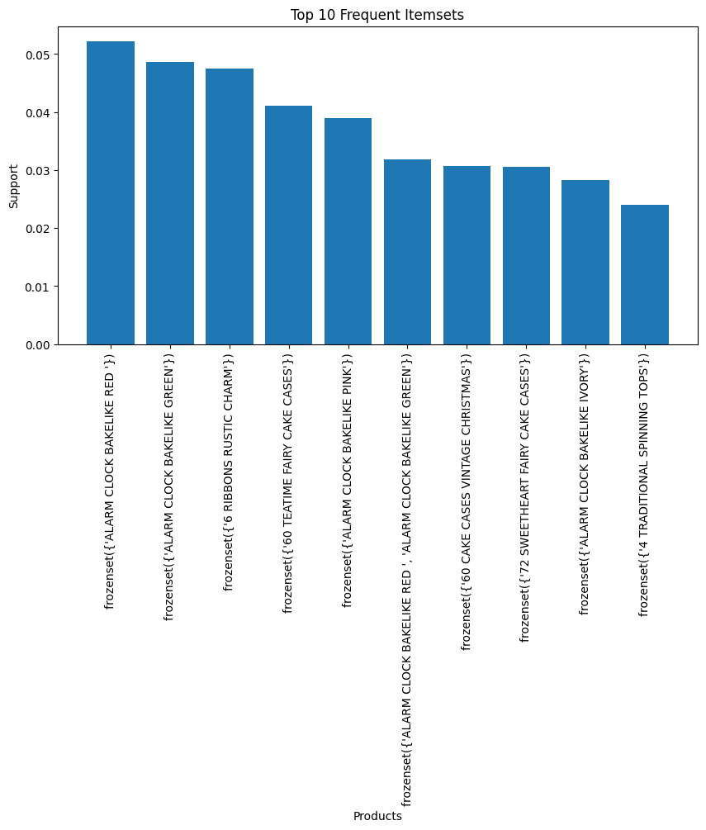
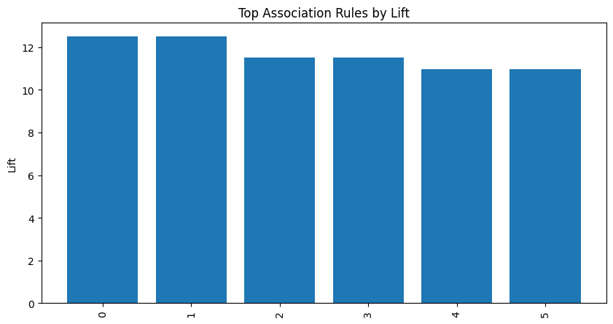

Findings
- Strong purchasing relationships exist among Bakelike Alarm Clock products.
- Customers purchasing one color variant often purchase other color variants.
- High lift values indicate significant product associations.
- Frequent itemsets reveal customer preferences and purchasing patterns.
Business Recommendations
- Bundle Red, Green, and Pink Alarm Clocks together.
- Display associated products during checkout.
- Implement recommendation systems.
- Create targeted promotional campaigns.
- Optimize product placement in online stores.
Conclusion
Market Basket Analysis was successfully performed using the Online Retail Dataset. The Apriori Algorithm identified significant associations among products, particularly among Bakelike Alarm Clock variants. The generated association rules provide valuable business insights that can improve cross-selling opportunities, customer satisfaction, and sales performance. The project demonstrates how data mining techniques can be applied to real-world retail data to support business decision-making.
References
- Online Retail Dataset – UCI Machine Learning Repository.
- Python Documentation.
- MLxtend Documentation.
- Pandas Documentation.
- Association Rule Mining Literature.

